E Inspector Requirements:

1. Agent shall be able to create account using the mobile application
2. Agent shall be able to login using his/her name.
3. Agent is able to create new case with its details.
4. Every case may contains the below fields before submitting :

* Case Title
* Case Description
* Incident URI
* Incident Audio
* Incident Location.
* Incident submission Date.
* Incident status.
* Incident Escalation Period.

1. Agent is able to use capture image either by using the mobile camera or by pic image from mobile gallery.
2. Agent is able to record voice note about the incident.
3. Agent is able to get his location using location service in the mobile app [GPS - Network].
4. Mobile App will get the user address using geocoding service.
5. Agent will see his location on google maps.
6. Agent is able to view list of cases submitted by him.
7. Agent is able to view list of cases assigned to him.
8. Agent is able to view list of submitted cases and not assigned to him .
9. Agent is able to tap on case to view its details/Info.
10. Agent is able to add comments on the case.
11. Agent is able to view Other Agents Comments.
12. Agent is able to view the case history.
13. Case history shall be all activity done on the case like the below :

* Case has been submitted.
* Case has been assigned to Agent.
* New voice note has been added.
* Incident image has been updated.
* Case has been resolved.
* Case has been escalated.
* Case has been closed.

**Data Base Diagram**

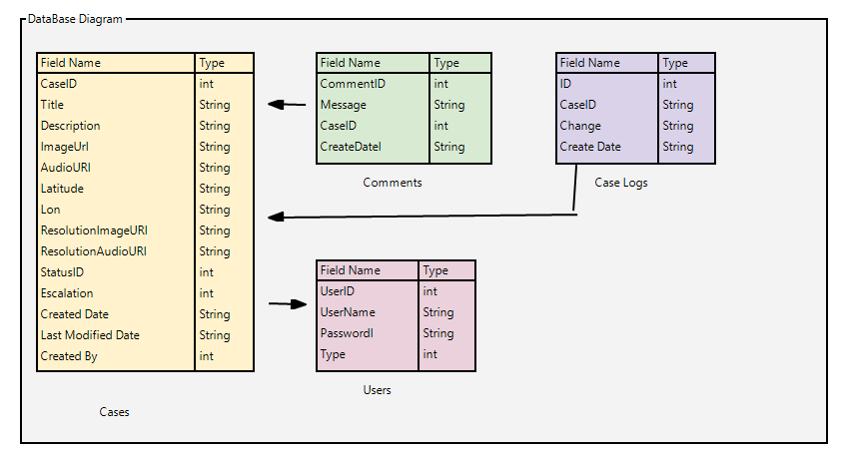

**Design Work flow:**

|  |  |
| --- | --- |
| E:\Work\1-ITWorx\Projects\EInspector\AllIntegrated\Design\01-einspector-Login.jpg | First User Login with the following attributes :   * Username * Password.   And press on the **Login Button**  To Register   * User can tap on Register * Register Screen Like the login except it has the name input field. |
| E:\Work\1-ITWorx\Projects\EInspector\AllIntegrated\Design\02-einspector-listcauses.jpg | Once Agent has been Login Successfully  App Will redirect the user to the A list of cases.  User can top on Case to view its   * Details * View Comments / Add * View Case History.   User can tap on the plus button to submit a new case |
| E:\Work\1-ITWorx\Projects\EInspector\AllIntegrated\Design\03-einspector-causedetails.jpg | Agent can tab on a case to view its details.  And using the tab bar to access   * History * Comments |
| E:\Work\1-ITWorx\Projects\EInspector\AllIntegrated\Design\04-einspector-causecomments.jpg | Comments List |
| E:\Work\1-ITWorx\Projects\EInspector\AllIntegrated\Design\05-einspector-createcause.jpg | Create new Case   * Title * Description * Assigned To * Escalation Date * Photo * Location * Voice Message |
|  |  |